FIT5125: IT Research and Innovation Methods
Assignment 2 (Task-A Report)
Name: Bharath Arun Gandhimani Student ID: 35501308

Research Question
How do varying Kluster system configurations—specifically the use of waiting lists and YouTube integration—affect both the diversity and depth of participant engagement, as measured by room hopping and session duration? This analysis aims to uncover whether changes to these features influence how dynamically and for how long users interact within the collaborative environment.

Descriptive Metrics

Variables used:
- room_hops from the "room_hops" sheet, representing the number of times participants switched rooms during sessions.
- session_duration_minutes from the "room_duration" sheet, summed per participant session, representing the total time spent engaged in the system.
Condition | Average Room Hops | Average Session Duration (minutes)
All Features + 50% Waiting List | 1.28 | 806.53
All Features + No Waiting List | 3.32 | 105.65
Without YouTube + 50% Waiting List | 1.41 | 171.49
Without YouTube + No Waiting List | 4.08 | 184.13

Justification:
Average room hops measure navigation diversity, indicating how actively participants explore collaboration spaces. Average session duration quantifies the depth of engagement by capturing total time invested in the system. Together, these complementary metrics reveal differences in both behavioral variety and sustained involvement across all four experimental conditions, making them ideal for understanding the participant engagement impacts of the system features and waiting list configurations.

Visualization
The chart below displays average room hops and session duration (minutes) for each experimental condition. Log scaling is applied to make both metrics visible, and precise values are annotated above each bar.
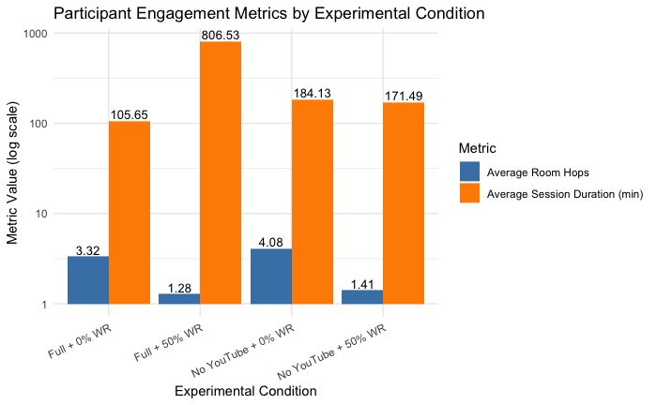

Findings Narrative
The analysis clearly demonstrates how system configurations in the Kluster Networking Challenge affect both the diversity and depth of participant engagement, as evidenced by the two selected metrics—average room hops and average session duration—highlighted in the accompanying visualization. The "All Features + 50% Waiting List" condition results in the longest session duration, averaging over 800 minutes per participant, indicating deep engagement but low diversity of interaction, reflected in minimal room hops (1.28). This suggests that waiting lists prolong participant involvement but constrain exploratory behavior within fewer collaboration spaces.
Conversely, the "Without YouTube + No Waiting List" condition exhibits the highest room hopping frequency (4.08) alongside considerable session duration (~184 minutes), highlighting dynamic and purposeful movement between rooms when system constraints are minimal. This enhanced room switching suggests broader interaction diversity despite less sustained session time compared to waiting list conditions.
Intermediate conditions ("All Features + No Waiting List" and "Without YouTube + 50% Waiting List") demonstrate moderate engagement in both metrics, illustrating the independent and additive impacts of feature inclusion and flow control on user behavior.
Collectively, these insights from the metrics and visualization imply that designing effective collaborative systems requires balancing media feature provision, like YouTube access, with participant management mechanisms, such as waiting lists. While features encourage engagement depth, flow controls shape interaction variety. A thoughtful equilibrium can foster both sustained participation and exploratory interaction, optimizing collaborative experiences for users.

